# SBAC (Smarter Balanced test)

The Smarter Balanced test will offer ALL students a range of tools to complete their tasks. “Universal Tools” will be digitally-delivered components or separate. It is important to teach our students these tools before they take the test so they have access to the resources. Below are a few.

* Calculator: an embedded on-screen calculator when students click it. This tool is only available for some items where Smarter Balance has deemed it appropriate.
* Math tools: Digital tools like rulers and protractors are available for geometry items where Smarter Balance has deemed it appropriate.
* Scratch paper: Graph paper must be used for grades 6 and above for Math. Lined paper may be used for ELA.
* English dictionary: An English dictionary for the full write portion of an ELA performance task. The full write portion is the second part of a performance task.
* Spell Check: A spell check that checks spelling but does not provide the correct spelling. This is also available only on the full write portion.
* Highlighter: A digital tool for marking desired text, item questions, item answers, or parts of these with a color.
* Mark for review: Allows students to flag items for future review during the assessment.

For the complete list: <http://www.smarterbalanced.org/wordpress/wp-content/uploads/2013/09/SmarterBalanced_Guidelines_091113.pdf>

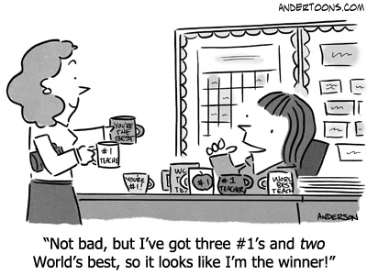

AG-TLC Directives

Whiteboards

Think, Pair, Share

Random Selection

Cornell Notes

Depth of Knowledge questioning

Thinking Maps

Use a multi flow map for prediction. Going into the center are the events leading up to the event. In the center box is the event. Coming out of the event are student predictions. Can be used as a review of previous readings or at a cliffhanger in the text.

Staff Shout-outs

Thank you to Eric Antuna, Tami Leroux, Yadira Milward, and Angela Whittaker for all of their support in making the Winter Program a success! Also to Gail Bobro, Maria Tota, and Christeena Lozano for their class contributions to making the decorations for the event!



Principal Ryan Saunders

Assistant Principal Eric Antuna

1/13/13

Issue 12

Painted Hills Teacher Newsletter